**TASK 1:**

#include <iostream>

using namespace std;

struct Node

{

int key, height;

Node* L, * R;

};

class Tree

{

private:

Node* root;

Node* addNode(int key) {

Node* ptr = new Node;

ptr->key = key;

ptr->L = ptr->R = NULL;

ptr->height = 1;

return ptr;

}

int BalFactor(Node* T) {

if (T == NULL)

return 0;

return HEight(T->L) - HEight(T->R);

}

int HEight(Node* T) {

if (T == NULL) {

return 0;

}

return T->height;

}

int getMax(int x, int y) {

if (x > y)

return x;

return y;

}

Node* rotateRight(Node* K2) {

Node* K1 = K2->L;

Node* temp = K1->R;

K1->R = K2;

K2->L = temp;

K2->height = getMax(HEight(K2->L), HEight(K2->R)) + 1;

K1->height = getMax(HEight(K1->L), HEight(K1->R)) + 1;

return K1;

}

Node* rotateLeft(Node* K1) {

Node* K2 = K1->R;

Node* temp = K2->L;

K2->L = K1;

K1->R = temp;

K1->height = getMax(HEight(K1->L), HEight(K1->R)) + 1;

K2->height = getMax(HEight(K2->L), HEight(K2->R)) + 1;

return K2;

}

public:

Tree() {

root = NULL;

};

Node* getRoot() { return root; }

Node* insertNode(Node* T, int key) {

if (T == NULL) {

Node* ptr = addNode(key);

return ptr;

}

if (key < T->key)

T->L = insertNode(T->L, key);

if (key > T->key)

T->R = insertNode(T->R, key);

T->height = 1 + getMax(HEight(T->L), HEight(T->R));

int factor = BalFactor(T);

if (factor > 1 && key < T->key)

{

cout << "Right Rotation takes place." << endl;

return rotateRight(T);

}

if (factor < -1 && key > T->key)

{

cout << "Left Rotation takes place." << endl;

return rotateLeft(T);

}

if (factor > 1 && key > T->key)

{

cout << "Left Right Rotation takes place." << endl;

T->L = rotateLeft(T->L);

return rotateRight(T);

}

if (factor < -1 && key < T->key)

{

cout << "Left Right Rotation takes place." << endl;

T->R = rotateRight(T->R);

return rotateLeft(T);

}

return T;

}

void inorderPrint(Node* T) {

if (T == NULL)

return;

inorderPrint(T->L);

cout << T->key << " ";

inorderPrint(T->R);

}

};

int main()

{

Tree tree;

Node* T = tree.getRoot();

int opt, num;

bool exit = false;

while (!exit)

{

cout << "Press 1 for Inserting values" << endl;

cout << "Press 2 for Printing values" << endl;

cout << "Press 3 to Exit" << endl;

cout << "Your Option is: ";

cin >> opt;

switch (opt)

{

case 1:

cout << "Enter element: ";

cin >> num;

T = tree.insertNode(T, num);

break;

case 2:

cout << "Inorder print of Tree: ";

tree.inorderPrint(T);

cout << endl;

break;

case 3:

exit = true;

break;

default:

cout << "Option is invalid!" << endl;

}

system("pause");

system("cls");

}

}

**OUTPUT:**

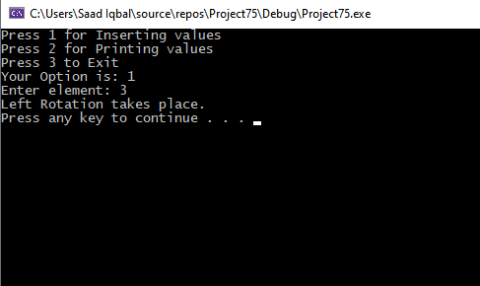

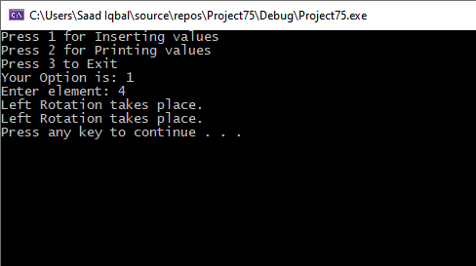

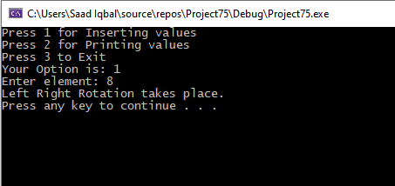

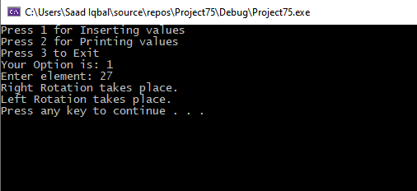

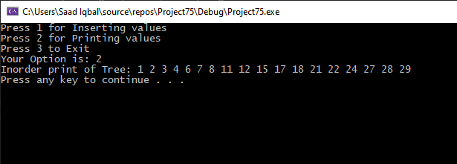

**TASK 2:**

#include <iostream>

using namespace std;

struct Node

{

int key, height;

Node* L, * R;

};

class Tree

{

private:

Node* root;

Node* addNode(int key) {

Node* ptr = new Node;

ptr->key = key;

ptr->L = ptr->R = NULL;

ptr->height = 1;

return ptr;

}

int BalFactor(Node* T) {

if (T == NULL)

return 0;

return HEight(T->L) - HEight(T->R);

}

int HEight(Node* T) {

if (T == NULL) {

return 0;

}

return T->height;

}

int getMax(int x, int y) {

if (x > y)

return x;

return y;

}

Node* rotateRight(Node* K2) {

Node* K1 = K2->L;

Node* temp = K1->R;

K1->R = K2;

K2->L = temp;

K2->height = getMax(HEight(K2->L), HEight(K2->R)) + 1;

K1->height = getMax(HEight(K1->L), HEight(K1->R)) + 1;

return K1;

}

Node* rotateLeft(Node* K1) {

Node* K2 = K1->R;

Node* temp = K2->L;

K2->L = K1;

K1->R = temp;

K1->height = getMax(HEight(K1->L), HEight(K1->R)) + 1;

K2->height = getMax(HEight(K2->L), HEight(K2->R)) + 1;

return K2;

}

public:

Tree() {

root = NULL;

};

Node* getRoot() { return root; }

Node* insertNode(Node* T, int key) {

if (T == NULL) {

Node* ptr = addNode(key);

return ptr;

}

if (key < T->key)

T->L = insertNode(T->L, key);

if (key > T->key)

T->R = insertNode(T->R, key);

T->height = 1 + getMax(HEight(T->L), HEight(T->R));

int factor = BalFactor(T);

if (factor > 1 && key < T->key)

{

cout << "Right Rotation takes place." << endl;

return rotateRight(T);

}

if (factor < -1 && key > T->key)

{

cout << "Left Rotation takes place." << endl;

return rotateLeft(T);

}

if (factor > 1 && key > T->key)

{

cout << "Left Right Rotation takes place." << endl;

T->L = rotateLeft(T->L);

return rotateRight(T);

}

if (factor < -1 && key < T->key)

{

cout << "Left Right Rotation takes place." << endl;

T->R = rotateRight(T->R);

return rotateLeft(T);

}

return T;

}

int getLeafCount(Node* Node)

{

if (Node == NULL)

{

return 0;

}

else if (Node->L == NULL && Node->R == NULL)

{

return 1;

}

else

{

return (getLeafCount(Node->L) + getLeafCount(Node->R));

}

}

void inorderPrint(Node* T)

{

if (T == NULL)

return;

inorderPrint(T->L);

cout << T->key << " ";

inorderPrint(T->R);

}

};

int main()

{

Tree tree;

Node* T = tree.getRoot();

int opt, num;

bool exit = false;

while (!exit)

{

cout << "Press 1 for Inserting values" << endl;

cout << "Press 2 for Inorder display" << endl;

cout << "press 3 to print leaf counts " << endl;

cout << "Press 4 to Exit" << endl;

cout << "Your Option is: ";

cin >> opt;

switch (opt)

{

case 1:

cout << "Enter element: ";

cin >> num;

T = tree.insertNode(T, num);

break;

case 2:

cout << "Inorder print of Tree: ";

tree.inorderPrint(T);

cout << endl;

break;

case 3:

cout << "Number of leaf node are: ";

cout<<tree.getLeafCount(T);

cout << endl;

break;

case 4:

exit = true;

break;

default:

cout << "Option is invalid!" << endl;

}

system("pause");

system("cls");

}

}

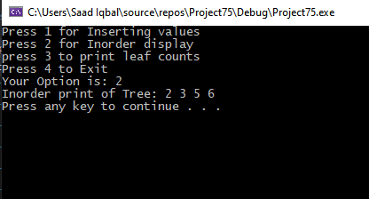

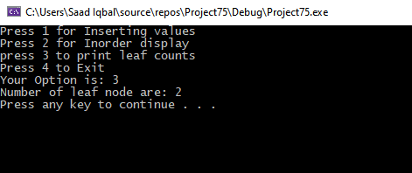

**TASK 3:**

#include <iostream>

using namespace std;

struct Node

{

int key, height;

Node* L, * R;

};

class Tree

{

private:

Node* root;

Node* addNode(int key) {

Node* ptr = new Node;

ptr->key = key;

ptr->L = ptr->R = NULL;

ptr->height = 1;

return ptr;

}

int BalFactor(Node* T) {

if (T == NULL)

return 0;

return HEight(T->L) - HEight(T->R);

}

int HEight(Node* T) {

if (T == NULL) {

return 0;

}

return T->height;

}

int getMax(int x, int y) {

if (x > y)

return x;

return y;

}

//Rotate right function for balancing

Node* rotateRight(Node* K2)

{

Node* K1 = K2->L;

Node* temp = K1->R;

K1->R = K2;

K2->L = temp;

K2->height = getMax(HEight(K2->L), HEight(K2->R)) + 1;

K1->height = getMax(HEight(K1->L), HEight(K1->R)) + 1;

return K1;

}

//Rotate Left function for balancing

Node* rotateLeft(Node* K1)

{

Node* K2 = K1->R;

Node* temp = K2->L;

K2->L = K1;

K1->R = temp;

K1->height = getMax(HEight(K1->L), HEight(K1->R)) + 1;

K2->height = getMax(HEight(K2->L), HEight(K2->R)) + 1;

return K2;

}

//Rotate left right function for balancing

Node* left_right_rotation(Node* node)

{

node->L = rotateLeft(node->L);

return rotateRight(node);

}

//Rotate right left function for balancing

Node* right_left_rotation(Node* node)

{

node->R = rotateRight(node->R);

return rotateLeft(node);

}

public:

Tree() {

root = NULL;

};

Node* getRoot() { return root; }

Node* insertNode(Node* T, int key) {

if (T == NULL) {

Node* ptr = addNode(key);

return ptr;

}

if (key < T->key)

T->L = insertNode(T->L, key);

if (key > T->key)

T->R = insertNode(T->R, key);

T->height = 1 + getMax(HEight(T->L), HEight(T->R));

int factor = BalFactor(T);

if (factor > 1 && key < T->key)

{

cout << "Right Rotation takes place." << endl;

return rotateRight(T);

}

if (factor < -1 && key > T->key)

{

cout << "Left Rotation takes place." << endl;

return rotateLeft(T);

}

if (factor > 1 && key > T->key)

{

cout << "Left Right Rotation takes place." << endl;

return left_right_rotation(T);

}

if (factor < -1 && key < T->key)

{

cout << "Left Right Rotation takes place." << endl;

return right_left_rotation(T);

}

return T;

}

//print display of tree

void display(Node* r, int space)

{

if (r == NULL)

{

return;

}

display(r->R, space);

cout << endl;

cout << r->key << "\n";

display(r->L, space);

}

//print inorder of tree

void inorderPrint(Node* T)

{

if (T == NULL)

return;

inorderPrint(T->L);

cout << T->key << " ";

inorderPrint(T->R);

}

//print preorder of tree

void print_preorder(Node* node)

{

if (node == NULL)

{

return;

}

else

{

cout << node->key << " ";

inorderPrint(node->L);

inorderPrint(node->R);

}

}

//print postorder of tree

void print_postorder(Node* node)

{

if (node == NULL)

{

return;

}

else

{

inorderPrint(node->L);

inorderPrint(node->R);

cout << node->key << " ";

}

}

//height of tree

int height(Node* t)

{

int h = 0;

if (t != NULL)

{

int l_height = height(t->L);

int r_height = height(t->R);

int max_height = max(l_height, r_height);

h = max_height + 1;

}

return h;

}

//difference of tree

int difference(Node* t)

{

int l_height = height(t->L);

int r_height = height(t->R);

int b_factor = l_height - r_height;

return b_factor;

}

};

int main()

{

Tree tree;

Node* T = tree.getRoot();

int opt, num;

bool exit = false;

while (!exit)

{

cout << "Press 1 for Inserting values" << endl;

cout << "Press 2 for display" << endl;

cout << "Press 3 for Inorder display" << endl;

cout << "Press 4 for preorder display" << endl;

cout << "Press 5 for postorder display" << endl;

cout << "press 6 to print height of tree " << endl;

cout << "press 7 to print difference of tree " << endl;

cout << "Press 8 to Exit" << endl;

cout << "Your Option is: ";

cin >> opt;

switch (opt)

{

case 1:

cout << "Enter element: ";

cin >> num;

T = tree.insertNode(T, num);

break;

case 2:

cout << "Display of Tree: ";

tree.display(T,5);

cout << endl;

break;

case 3:

cout << "Inorder print of Tree: ";

tree.inorderPrint(T);

cout << endl;

break;

case 4:

cout << "Preorder print of Tree: ";

tree.print_preorder(T);

cout << endl;

break;

case 5:

cout << "postorder print of Tree: ";

tree.print_postorder(T);

cout << endl;

break;

case 6:

cout << "Height of tree is : ";

cout<<tree.height(T);

cout << endl;

break;

case 7:

cout << "Difference of tree is : ";

cout << tree.difference(T);

cout << endl;

break;

case 8:

exit = true;

break;

default:

cout << "Option is invalid!" << endl;

}

system("pause");

system("cls");

}

}

